Date access: 2020-03-09

<http://wjw.beijing.gov.cn/wjwh/ztzl/xxgzbd/gzbdyqtb/202001/t20200130_1621743.html>

From 21:00 on January 26th to 9:00 on the 27th, 4 new cases of pneumonia infected with new coronavirus were added in this city

Date: 2020-01-27 Source: Beijing Municipal Commission of Health

        At 21:00 on January 26th to 9:00 on the 27th, four new cases of pneumonitis infected with a new coronavirus were added to the city. One of the close contacts of previously confirmed cases has been sent to designated medical institutions for treatment.

As of 9:00 on January 27, the city has accumulated 72 confirmed cases, including 1 in Dongcheng District, 7 in Xicheng District, 11 in Chaoyang District, 17 in Haidian District, 4 in Fengtai District, 2 in Shijingshan District, and 6 in Tongzhou District There were 1 case in Shunyi District, 5 cases in Daxing District, 7 cases in Changping District, and 11 cases came from overseas.

**1月26日21时至27日9时，本市新增4例新型冠状病毒感染的肺炎病例**

日期：2020-01-27 来源：北京市卫生健康委‍

        1月26日21时至27日9时，本市新增4例新型冠状病毒感染的肺炎病例，其中1名为此前确诊病例的密切接触者，目前均已送至定点医疗机构进行救治。

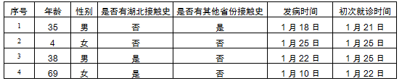

        截至1月27日9时，本市累计确诊病例72例，其中东城区1例、西城区7例、朝阳区11例、海淀区17例、丰台区4例、石景山区2例、通州区6例、顺义区1例、大兴区5例、昌平区7例，外地来京人员11例。